LSHTM Space Temperature Heating and Cooling Guidance

LSHTM Space Temperature Guide
Over-heating or over-cooling our buildings results in a major source of energy waste and this can significantly increase our utility cost and carbon emissions. Adhering to agreed temperature parameters will help reduce this impact and cost. Thus providing more alignment with the energy efficiency hierarchy (schematic below), and with LSHTM’s commitment to achieve net zero carbon emissions by 2030.
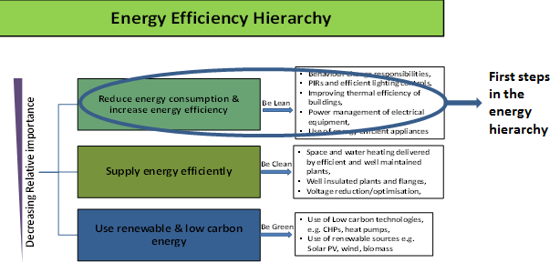
Furthermore, this will complement the controls strategy for the School’s BMS systems and help achieve cost savings on utilities spend while maintaining reasonable levels of comfort across the estate.
Heating and Cooling
This section sets out parameters that will help the School achieve efficiencies in heating and cooling operations whilst maintaining adequate levels of comfort for occupants.
According to HSE guidance, the law requires employers to ensure - ‘During working hours, the temperature in all workplaces inside buildings shall be reasonable.’ This can vary markedly depending on the kind of activities being carried out within the spaces. Guidance from the HSE’s code of practice suggests that minimum temperature in an office space should not go below 16ºC, and maximum temperatures should provide ‘reasonable’ levels of comfort – there is no stipulated legal maximum.
Therefore, save for exception areas, the following heating and cooling regime can be implemented across the School;
- Heating and cooling season – By default heating will be turned on by end of October and switched off by end of March. However, this will depend on the severity of the winter and summer months.
- Heating and cooling times – 7am to 9pm, Monday to Friday in most areas. Library and teaching spaces which open longer will have extended heating and cooling provisions.
- Minimum and maximum heating and cooling temperatures – The School will seek to maintain temperatures in most areas at 20ºC with a ±2ºC control variance allowance. Therefore, lower limit 18ºC and upper limit up to 23ºC, are within reasonable range. In peak summer months where air conditioning is provided active cooling will be activated at 25ºC to bring down to minimum temperature of 22 ºC.
- Corridors and circulation spaces shall not be heated above 18ºC where control is possible.
Areas of Exception – this guidance will not be enforced in areas such as server rooms, cold rooms, biological services areas and some laboratories where temperature sensitivities are a factor. NB – in some spaces air conditioning may be turned off and windows kept open instead to reduce infection risks. (Note – Due to Covid-19 as occupancy increases there may be instances where windows may need to left open in air-conditioned spaces but in most cases the a/c would be turned off).
This guidance will also be used to set temperature control mechanisms for new builds and refurbishments projects. And where infrastructure does not allow for automated controls, management procedures will be adopted to help deliver outcomes which align with the recommendations of the guidance.
Space Heating and Cooling Temperature at Some London Universities
It should be noted that LSHTM is not alone in having a space temperature procedure. A number of institutions in London already have temperature policies in place. Below is a list of some of them.
London University Temperature Policy Range | Min | Max
Kings College | 18 ºC | 26 ºC
Imperial College | 19 ºC | 28 ºC
UCL | 19 ºC | 25 ºC
Queen Mary University | 19 ºC | 26 ºC
London Metropolitan University | 19 ºC | 26 ºC
Occupants Code of Conduct;
- Wear clothing appropriate for external weather conditions. If the weather outside is cold, then the internal temperature will be impacted.
- Opening windows and doors during the summer to create a through-flow of fresh air. (NB – all windows and doors must be kept closed in air-conditioned areas).
- Switching off electrical equipment and lighting when not needed to reduce need for cooling.
- Report any problems to the Estates Department Helpdesk including damages to windows and doors. Portable air conditioners or portable electric heaters must NOT be used unless supplied by Estates.
- If special consideration is required by some individuals due to health reason then managers should contact the health and safety office.
The temperatures stated in this guidance are in line with institutions with similar buildings and operations. This guidance will be reviewed annually with due consideration to trends in severity or mildness of the winter and summer months.

LSHTM Estates Department

-----------------------------------------------------
John Starmer

HSE Guidance – http://www.hse.gov.uk/temperature/law.htm

