Sustainability Group Case study
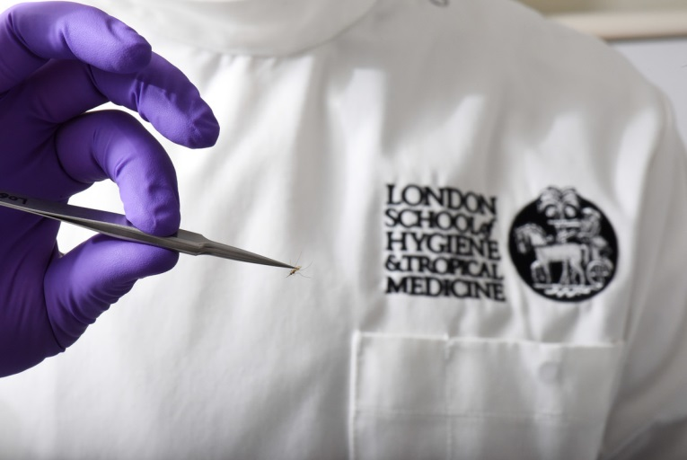
Deborah Coles has been managing the laboratories within LSHTM for the past 12 years, and during this time she has implemented a variety of good-practice initiatives with an eye to helping our planet. These include: reducing freezer numbers by proposing a two old for one new freezer incentive, developing a freezer policy (and enforcing it), having the autoclaves modified to reduce water consumption, greatly reducing daily autoclave runs through developing an online haz-waste booking system, introducing new recycling bins to help reduce incinerated packaging, helping to develop an equipment Swap-Shop, aiding in efficient equipment procurement, and more. Crucially Deborah gained senior support for her initiatives in the form of significant financial support – raising at least £15,000 per annum to fund the various initiatives.
Integrating sustainability into laboratory working practices is not easy, but everything is made easier when done as a team. Deborah, recognising this, initiated the LSHTM Laboratory Sustainability Group. To maximise their reach and local knowledge, every department had a member present (Disease Control Dept, Immunology & Infection Dept, Pathogen and Molecular Biology Dept, Clinical Research Dept, Biological Services Facility, teaching, the Faculty Safety Supervisor, and a student representative). Members are permanent though are replaced after should they depart. Today the group meets on a quarterly basis, and participation is open to all LSHTM staff and students.
The group has transformed good will into measurable savings and visible improvements in good practice. Ongoing and previous successes include raising the of ultra-low temperature (ULT) freezer temperatures from -80C to -70C. Each freezer’s energy consumption is comparable with that of the average consumption of a UK household. Raising their temperature by just 10C to -70C from -80C has been shown to save an incredible 30% on energy consumption, meaning that each year at least £8,000 in energy is being saved (or the equivalent of 12 homes). Beyond freezers, the group has assisted in piloting new recycling bins within laboratories to promote recycling of packaging and avoiding it being incinerated. Such bins have resulted in the diversion of at least 7 tonnes of clinical waste, directly reducing the amount of pollution produced by LSHTM laboratories. Impressively, Deborah recently had laboratory services and sustainability added to the college’s service desk portal. Currently being developed, this will facilitate a process to deal with sustainability and lab inquiries
While plenty has been done, there is plenty left to do, and input from staff and students is often how initiatives are started. Get in contact with Deborah Coles to learn more about how you can join, and what you can do to make our Faculty as sustainable as possible.

LSHTM Laboratory Swap-Shop
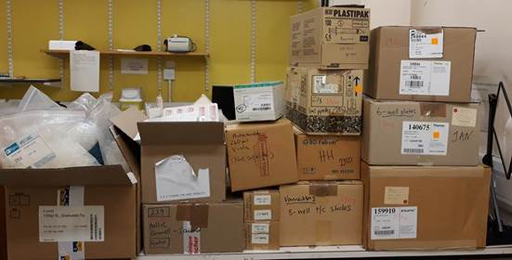
Laboratory equipment and consumables can be extremely costly, both financially and to the environment. Many techniques in research require sterile and clean environments, which are typically achieved through combinations of high heat exposure, chemical products, and simply via single-use items. All of these processes can be extremely demanding on energy consumption and waste treatment, and thus minimising these can have significantly positive impacts.
LSHTM possesses guidance on sustainable procurement which may be found here, as well as guidance specific to efficient laboratory equipment which may be found here. Often though equipment and materials can get leftover due to departing staff and changes to experimental design. Identifying this, Deborah Coles and the laboratory sustainability group started the LSHTM Swap-Shop for laboratories.
What started with a fun idea of sharing leftover materials at Christmas via emails became an annual exchange in April. Now it has transformed into an established process appreciated by all within LSHTM laboratories. The Faculty’s monthly bulletin contains all available consumables and equipment, which otherwise might go to waste. There is now a dedicated space near the labs where items are stored before being claimed. Any Equipment not claimed is recycled through the UniGreen Scheme. Each year tens of thousands of pounds worth of equipment and consumables no longer are thrown away, and in doing so our staff time and money for more research. We estimate that at least £120,000 has been saved in waste and procurement costs. This has been complemented by the recent employment of a service by Deborah which takes away old lab equipment and either repairs and sells on or has it disposed of. Between these two services, the college is sure to enable incredible savings, not just financially but with people’s time.
If you have items that you want to offer, contact Deborah Coles or Elizabeth King Otherwise and check the monthly newsletter. Any departing staff should consider using the Swap-Shop instead of the bin!

